*Angiogenesis: A Literature Review*

David Dorneau

*Department of Engineering and Computer Science*

*Florida Atlantic University*

Boca Raton, Florida

[ddorneau2014@fau.edu](mailto:ddorneau2014@fau.edu)

***Abstract -*  Angiogenesis, the formation of new blood vessels, plays critical roles in the human physiology, which range from fetal growth to tissue repair, and the female reproductive cycle. Contrary to this, imbalanced angiogenesis can result in vascular insufficiency and vascular overgrowth (retinopathies, hemangiomas, and vascularized tumors). The balance between pro-angiogenic and antiangiogenic growth factors tightly controls angiogenesis. As a result, in recent years, it has been found that through understanding and successful manipulation of these factors, angiogenesis can be used for therapeutic purposes. In this paper, we discuss the clinical implications of angiogenesis, and the pro-angiogenic and antiangiogenic agents that offer potential therapy for cancer and other angiogenic diseases.**

***Keywords - Blood vessel, cancer, angiogenesis, disease, and agents.***

1. Introduction

Angiogenesis, the word angio meaning blood vessel and genesis meaning creation, is the creation of new blood vessels. Angiogenesis is a crucial process, which occurs during health, as well as disease. The formation of new tissues involves the formation of new blood vessels. When new tissue is formed, it is essential that is has blood supply for its growth and livelihood. For this reason, the creation of new blood vessels or angiogenesis is important. Situations where angiogenesis is vital and necessary include the repair of wounds, as well as the formation of the placenta during pregnancy.

1. Angiogenic factors

A variety of signaling molecules such as Fibroblast growth factors (FGF), Vascular endothelial growth factors (VEGFs) and receptors (VEGFRs) , Ephrin-eph receptors, and angiopoietin-Tie have been identified as playing important roles in angiogenesis. The VEGFs and VEGFRs regulate angiogenesis and vasculogenesis, the development of blood vessels from precursor cells during the early embryogenesis.

The VEGFR family of genes contains 3 to 4 members, entirely dependent on the vertebrae species, whereas the VEGF family of genes contains at least 7 members.The members of VEGF family are VEGF-A VEGF-B, VEGF-C, VEGF-D, PIGF, VEGF-E, and svVEGF. Amongst these, the first 5 can be found in humans. The members of the VEGFR family are VEGFR-1, VEGFR-2, and VEGFR-3. Members of the VEGF family stimulate cellular responses by binding to the VEGFRs on the cell surface.

1. Processes in Angiogenesis

According to Yoo and Kwon, 2013, the process of angiogenesis occurs as follows:

1. Angiogenic factors FGF and VEGF bind to their receptors on endothelial cells and activate the signal transduction pathways.
2. Matrix metalloproteinases ae activated, and degrade the extracellular matrix.
3. Endothelial cells migrate out of the preexisting capillary wall and proliferate.
4. Integrins are expressed by endothelial cells, facilitating their adhesion to the extracellular matrix and their migration for tube formation.
5. Angiopoietin 1 binds to Tie-2 receptors and simulates pericyte recruitment and vessel stabilization.
6. Angiogenesis in clinical trials

Unusual angiogenesis is said to be the major cause of many diseases. By unusual, we mean either excessive or insufficient angiogenesis. This is said to be the cause of conditions which include skin diseases, cancer, age-related blindness, hemangiomas, and cardiovascular disease. One can assume that with medical help, angiogenesis can be balanced, to reduce the effects or possibly nullify the effects of said disease that previously occurred as a result of imbalance.

We’ve reached the discovery that medical treatment can be used to stimulate or inhibit angiogenesis, which can prolong the lives of cancer patients, reverse vision loss, and improve general health. Depicted in Table 1, are instances where angiogenesis needs to be inhibited in areas where it is rampant, or stimulated in areas where it is lacking, depending on the disease. New research suggests that through therapeutic angiogenesis, we may be able to save limbs afflicted with poor circulation, and regenerate damaged or lost tissues.

The vast majority of the development in treatment inhibiting angiogenesis has been directed towards cancer because of tremendous heterogeneity of different cancers and only one common feature of increased angiogenesis among different cancers. Angiogenesis plays a major role in the development and spread of cancer, because a blood supply is required for tumor growth and metastases. Tumors secrete chemical signals that stimulate angiogenesis and thus stimulate nearby cells. For this reason, antiangiogenic agents have been studied to slow or prevent the growth of cancer. These agents can have various effects on angiogenesis.

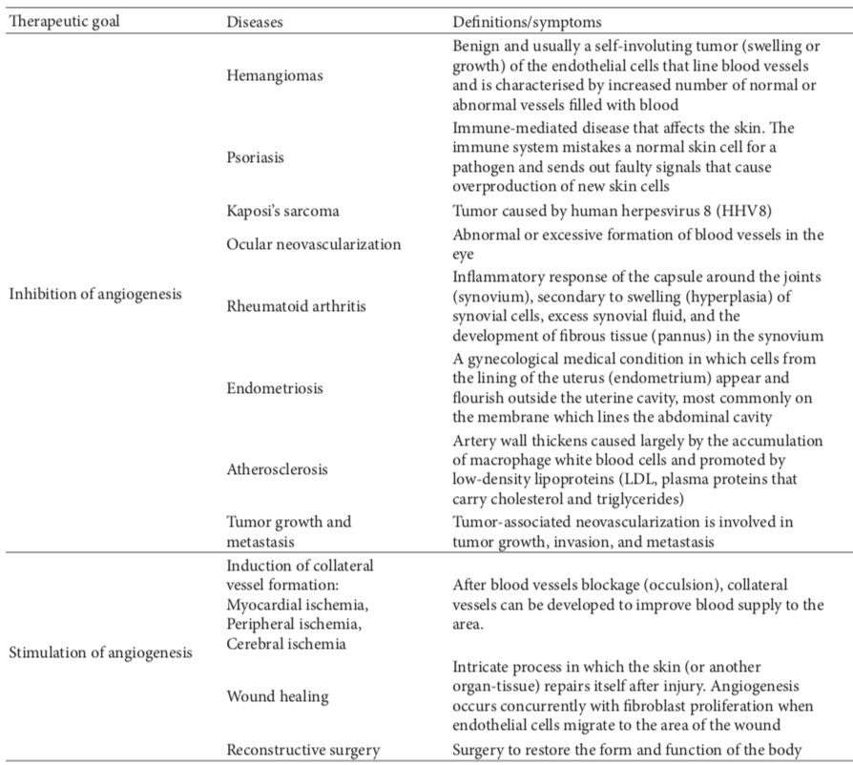

Table 1: Clinical manipulation of Angiogenesis (Yoo and Kwon, 2013).

Bevacizumab (Avastin) was the first FDA-approved angiogenesis inhibitor that was shown to slow tumor growth, and prolong the lives of patients with some cancers. Bevacizumab is a monoclonal antibody that specifically recognizes and binds to VEGF, which prevents VEGF from activating VEGFR. In contrast, other angiogenesis inhibitors (depicted in table 2), including sorafenib and sunitinib, bind to receptors on the ECs or to other proteins in the downstream signaling pathways to block their activities (Yoo and Kwon, 2013). Zhang, 2005 provides us with some of the major advantages of angiogenesis based treatments are over others:

1. A single vessel provides the nutrition for thousands of tumour cells and has to be damaged at only one point to block blood flow upstream and downstream.
2. The endothelial cell is a normal diploid cell, which is unlikely to acquire genetic mutations that render it drug Resistant.
3. Blood flow, a surrogate marker for biological activity, is measurable in the clinic.
4. Temporary effects on vascular function may be sufficient to kill the endothelial cells.
5. A change of shape of local initiation of blood coagulation may be sufficient, other than killing the endothelial cells.

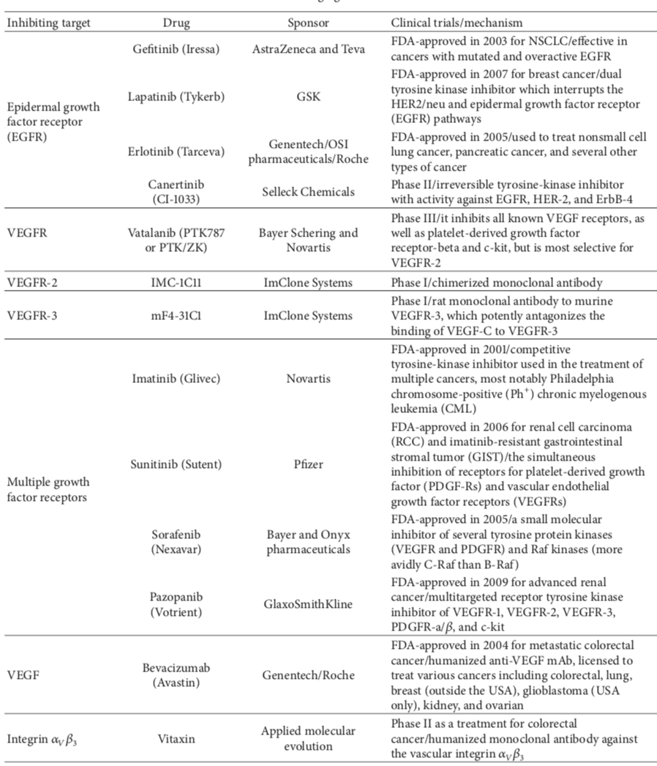

Table 2: Selected angiogenesis inhibitors in clinical trials (Yoo and Kwon, 2013).

1. Limitations of angiogenesis based treatments

Most of the angiogenesis based treatments have worked in experimental rodent models but have not been successful in clinical trials. First of all, anti-angiogenic treatments target actively proliferating endothelial cells. However, the relative number of proliferating EC is far smaller in human tumours than it is in rodent tumour models. Mature vessels in human tumour at any given time may not undergo regression with the conventional anti-angiogenic agents. Thus, additional markers associated specifically with specific pathological angiogenesis need to be identified. Secondly, multiple growth factors, receptors, and other components of the microenvironment support angiogenesis. Therefore, treatment targeted to a single factor may not be completely effective. It is not yet feasible to monitor the antiangiogenic response in the patients. However, with the recent advances in magnetic resonance imaging it may be possible to do vascular imaging in patient (Zhang, 2005).

1. Side effects of antiangiogenic therapy

A wide variety of side effects, such as renal dysfunction, hypertension, thrombosis, arrhythmia, proteinuria, cardiac failure, hair changes and bleeding, have been reported in patients under anti–VEGF-VEGFR therapy. Among these reports, the frequency of hypertension and proteinuria is higher than that of others, which suggests a direct relationship with the blockage of VEGF-A in tissues. A decrease in the level of VEGF-A in the kidney could induce damage to vascular endothelial cells in glomeruli, and such a dysfunction of glomerular microvasculature may cause proteinuria. In addition, in some preclinical and clinical trials, glioblastoma showed an enhanced invasiveness after anti-angiogenic therapy (Shibuya, 2011).

1. Methods

For the gathering of information, I took the simplest of routes. I used the most basic form of text mining, using the find feature (ctrl-f) of pdf readers and webpages, to look for terms related to angiogenesis, which helped me select the review papers that I did. In addition to that, I read the review papers, and while reading I highlighted important areas that I wanted to include in my paper. Later on I will look at other tools that can help me identify more sources, in order to elaborate on angiogenesis. As a part of the Go term enrichment, I have decided to use the KEGG pathway search tool to identify pathways related to angiogenesis, as well as related genes. Furthermore, I used the Princeton GO term finder tool to identify biological processes based on the genes that I found.

1. Results

|  |  |  |
| --- | --- | --- |
| **Genes/Gene products** | **Category** | **Major Function** |
| VEGF-A | inducer | Induction of EC proliferation |
| VEGF-B | inducer | Induction of EC proliferation |
| Angiopoietin 1 | inducer | Induction of EC proliferation |
| Angiostatin | inhibitor | Inhibit EC proliferation |
| Endostatin | inhibitor | Inhibit EC proliferation |
| interstitial collagenase (MMP-1) | Proteolytic enzyme | Degrading ECM components |
| collagenase-3 (MMP-13) | Proteolytic enzyme | Degrading ECM components |
| Ephrins | inducer | Induction of EC proliferation |
| Integrins | inducer | Induction of EC proliferation |
| Vasostatin | inhibitor | Inhibit EC proliferation |

Table 3: Angiogenesis gene products.

|  |  |
| --- | --- |
| **Genes/Gene products** | **Pathway discovered** |
| gp130 | Viral carcinogenesis |
| vIL-6 | Viral carcinogenesis |
| ARMS2 | Cell growth |
| HTRA1 | Cell growth |
| APOE | Atherosclerosis |
| Tie2 | Rheumatoid arthritis |
| TIMP3 | Extracellular matrix degradation |
| FILIP1L | Extracellular matrix |
| TGFBR1 | Angiogenesis |
| MMP9 | Proteoglycans in cancer |

Table 4: Pathway genes related to Angiogenesis.

|  |  |  |
| --- | --- | --- |
| **Pathways** | **Description** | **Status** |
| Proteoglycans in cancer | Proteoglycans (PGs) have been shown to be key macromolecules that contribute to biology of various types of cancer, including angiogenesis in affecting tumor growth. | Previously known pathway |
| Rheumatoid arthritis | Can promote synovial angiogenesis with abnormal activation of the immune system elevates pro-inflammatory cytokines and chemokines level. | New pathway |
| Cytokine-cytokine receptor interaction | Cytokines are glycoproteins that are crucial intercellular regulators of cells engaged in angiogenesis. | New pathway |
| Viral carcinogenesis | Via expression of many potent oncoproteins, tumor viruses can promote an aberrant cell-proliferation. | New pathway |
| VEGF signaling pathway | VEGFR-2 is the major mediator of VEGF-driven responses in endothelial cells and it is considered to be a crucial signal transducer in both physiologic and pathologic angiogenesis | Previously known pathway |
| Apelin signaling pathway | Apelin is an endogenous peptide capable of binding the apelin receptor and is implicated in the process of angiogenesis. | New pathway |

Table 5: Biological Pathways related to Angiogenesis.

|  |  |
| --- | --- |
| **Process** | **P-value** |
| regulation of epithelial cell proliferation | 0.01338 |
| regulation of endothelial cell proliferation | 0.01826 |
| regulation of membrane protein ectodomain proteolysis | 0.03718 |

Table 6: Biological processes related to Angiogenesis.

1. Discussion

As a result of this review, there is plenty to walk away with. I not only became familiarized with what angiogenesis is and the process, but also how it affects our livelihood and what factors can be used to control it. Furthermore, i’ve become acquainted with diseases and conditions that angiogenesis is associated with. I’ve identified uses for the clinical manipulation of angiogenesis, be it to induce, or inhibit EC proliferation, and the side effects of some of those manipulations. Lastly, i’ve identified gene products of angiogenesis. The most difficult part of this review was deciding where to focus because angiogenesis is involved in so many biological processes. One thing I wanted to come across but did not find was a hint to whether angiogenesis clinically manipulated or not can repair damage caused by heart conditions.

Following the Go Term enrichment, I have identified four new biological pathways related to angiogenesis. The first is Rheumatoid arthritis, which can promote synovial angiogenesis with abnormal activation of the immune system elevates pro-inflammatory cytokines and chemokines level. The second is Cytokine-cytokine receptor interaction; Cytokines are glycoproteins that are crucial intercellular regulators of cells engaged in angiogenesis. The third is Viral carcinogenesis, which via expression of many potent oncoproteins, tumor viruses can promote an aberrant cell-proliferation. Last but not least, Apelin signaling pathway; Apelin is an endogenous peptide capable of binding the apelin receptor and is implicated in the process of angiogenesis. With these new pathways, I can broaden my research on angiogenesis by branching into different pathways for information involving angiogenesis genes and gene products.

1. Conclusion

As a result of still being in the early stages of breakthroughs for angiogenesis, we face the challenge of creating a positive outlook for potential therapy for cancer and other angiogenic diseases. With every solution, there are repercussions and new factors that are discovered. Angiogenesis is already a complex process, so with every new factor, the complexity only increases. Despite this, angiogenic based drugs are still preferred over drugs like chemotherapeutic drugs.

1. References

[1] So Young Yoo and Sang Mo Kwon, “Angiogenesis and Its Therapeutic Opportunities,” Mediators of Inflammation, vol. 2013, Article ID 127170, 11 pages, 2013.

[2] Shibuya, M. (2011). Vascular Endothelial Growth Factor (VEGF) and Its Receptor (VEGFR) Signaling in Angiogenesis: A Crucial Target for Anti- and Pro-Angiogenic Therapies. Genes & Cancer, 2(12), 1097–1105.

[3] Gupta K, Zhang J Angiogenesis: a curse or cure? Postgraduate Medical Journal 2005;81:236-242.

[4] En.wikipedia.org. (n.d.). VEGF receptor. [online] Available at: https://en.wikipedia.org/wiki/VEGF_receptor [Accessed 22 Jan. 2019].

[5] Angio.org. (n.d.). Angiogenesis|The Angiogenesis Foundation. [online] Available at: https://angio.org/learn/angiogenesis/ [Accessed 27 Jan. 2019].